**IHE Work Item Proposal (Short)**

# **1. Proposed Work Item: Cardiology Consult and Pathology Board – Workflow Definition**

Proposal Editor:

* Claudio Saccavini, Elena Vio (evio@consorzioarsneal.it), Glauco Brandolino (gbrandolino@consorzioarsenal.it), Mauro Zanardini (mzanardini@consorzioarsenal.it) from Consorzio Arsenàl.IT (Italy) and IHE Italy;
* Charles Parisot (charles.parisot@med.ge.com), Harry Solomon (Harry.Solomon@med.ge.com)

Work item Editor: Mauro Zanardini, Elena Vio, Glauco Brandolino

Date: 16th October 2015

Version: 1.0

Domain: PCC

# **2.** **The Problem**

In many countries, the high healthcare specialization is centralized in order to make available widely health resources limited, because they are often very expensive. For this reason, the hub and spoke model between peripheral hospitals and highly specialized hospitals is expanding. This is the case of cardiac surgery. In order to guarantee an optimal treatment strategy in specific field such as stable CAD (Coronary Artery Disease), NSTEMI (non-ST elevation myocardial infarction) or aortic valve disease, Italy is moving to the creation of teams of professionals able to perform a complete analysis of the more complex clinical cases, thank to a network of hub. This team is called **“Heart Team” (HT)** (Figure 1) and they are responsible for the management of the clinical pathway for patients with cardiac disease (figure 2). The HT includes at least a cardiologist and the closer cardiac surgeon, that may belong to different enterprises or structures. Actually the use of informal consultations via phone, mail or email between cardiologists and cardiac surgeon is the most frequent approach adopted.

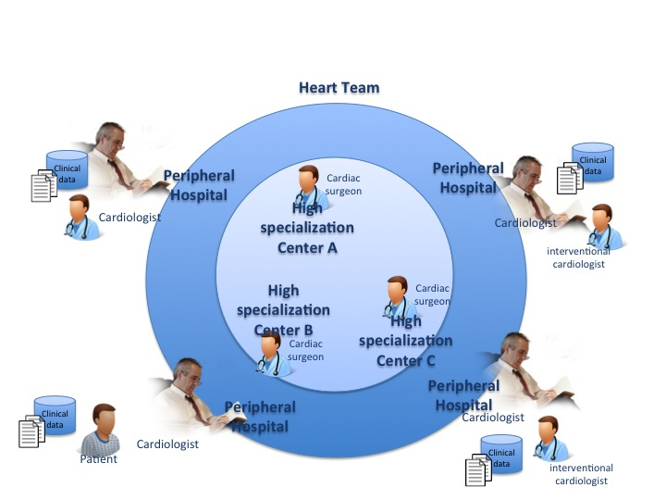

**Figure 1 Heart Team**

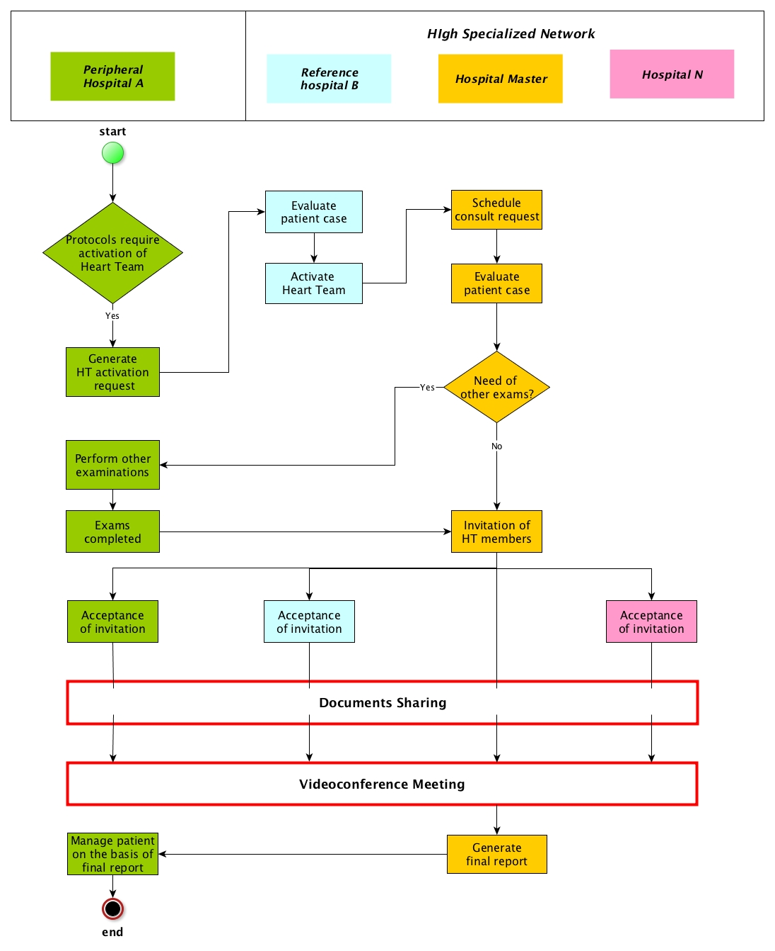

**Figure 2 Typical clinical pathway**

The management of the HT is not simple. The two units (cath lab and/or cardiological ambulatory and cardiac surgery department) may be remote, being sometimes in different geographical areas. Moreover, in many cases, in order to resolve the patient case, the heart team have to be extended, allowing the involvement of more different highly specialized centers with specific skills, belonged to different structures. In fact, a region can have highly specialized centers skilled in specific diseases, creating a network of hubs geographically distributed. For this reason, management of patient data may be difficult and time consuming. In this respect, health information systems which manage clinical records allowing interchange of structured data and images as well as cineloops may provide a significant improvement in overall patient management.

For these reasons, the aim of this proposal is to define a standardized workflow to manage and coordinate remote interaction between HT composed by network of hubs with high specialization on cardiac diseases and peripheral hospitals, with not only a simple sharing of information and digital documents, but also the activation of a multidisciplinary and dynamic team of healthcare professionals. The workflow will support and manage the activation of the dynamic HT that allows us to adapt the team to simple or complex cases.

This approach will enable:

* direct/dynamic enrolment of clinicians in a HT: clinicians are involved in process in relation of their skills and availabilities so that they can be activated promptly;
* Definition of a clear process for the highly specialized center to address heart team activation request: on the basis of the heart team activation request, the guidelines of the process identifies specific physicians of the HT to activate, the time of the response, which patient’s clinical exams have to be exchange, how to reach an agreement between HT members and which data should be reported to the requester.
* Standardization of the HT decisional process: specific documents have to be provide to HT, specific activities have to be carried out on the basis base of case of patient;
* Interaction/relationship with other clinical workflows related: workflow in HT can required input that are the final result of other workflows or triggers other activities managed from other workflows, for example reports produced a result from Referral Workflow, device’s data from Monitoring Workflow, etc.

**2.1 Impact**

The profile can be applied on a growing number of patients with cardiac problems. For example, on the world, 3.8 millions of man and 3.4 millions of female die for coronary heart disease each year (WHO, the global burden of disease: 2004 update). CAD is the most common type of heart disease and in 2008, 405,309 individuals died in the U.S. from this specific etiology. Every year, approximately 785,000 Americans suffer a first heart attack and another 470,000 will suffer an additional myocardial infarction (MI). In 2010, CAD alone was projected to cost the U.S. $108.9 billion including the cost of health care services, medications, and lost productivity. (http://www.clevelandclinicmeded.com/medicalpubs/diseasemanagement/cardiology/coronary-artery-disease/Default.htm).

# **3. Key Use Case**

**Use case #1 Activation and operating principles of the HT without IT infrastructure**

The following Use Case illustrates the Workflow for the activation of the cardiac clinical team (HT) and how it works in usual care.

Patient case

Wednesday, Dr. Smith (Hospital A), an interventional cardiologist in hospital A, visits a 67-year-old male patient with hypertension and without a previous history of cardiac disease started complaining of effort angina, CCS class III. The patient undergone to a cardiac echocardiogram to evaluate the heart functionality. The systolic function of the left ventricle was normal, with an ejection fraction of 60%. Dr. Smith decide to evaluate the patient with a coronary angiography the same week, revealing critical (90%) stenosis at the ostium of the left anterior descending (LAD) and left circumflex (LCX) coronary arteries, and diffuse disease of the right coronary artery (RCA). SYNTAX score is 20.

Patients with a multi-vessels stenosis and with SYNTAX score ≤22 shall be discussed in a weekly HT (http://www.ncbi.nlm.nih.gov/pubmed/23166211).

Request

Dr. Smith sends a message to Dr. Johnson, the closer cardiac surgeon in Hospital B, asking for discussion of his patient at the next HT Review meeting. The request it is sended via mail, and contains main clinical patient data but not diagnostic images and videos.

Schedule

Dr Johnson reviews the case and decides to insert the discussion of the case in the next HT review meeting, that will be tomorrow. He informs Dr. Smith that the case is very urgent and it will be discussed tomorrow, and an other hospital C will be involved in the discussion because it is very skilled in this case. Dr. Smith informs Dr. Johnson that can’t supply videos within tomorrow. Dr. Johnson decides to shift the discussion of the case to the next week, increasing the decision time for the best patient treatment.

Invitation

Dr. Johnson invite Dr. Rossi to the next HT review meeting because need his skill. Dr.Rossi confirms his attending.

Preparation

Dr. Smith delivers all diagnostic images and videos (recorded in CD-ROMs) to the hospital B and/or C with an express courier service.

HT Meeting

The HT, composed by Hospital A, Hospital B and Hospital C, reviews clinical data, diagnostic images and video and on the basis of guidelines, decides for a CABG (Coronary Artery Bypass Graft) intervention.

Final Report

A final Decision Report is sent to the Dr. Smith with the final assessment report, including specific reasons about the decision and the indications for the patient arrangements.

**Use case #2 Activation and operating principles of the Heart Team with an IT infrastructure**

The following Use Case illustrates the Workflow for the activation of the cardiac clinical team (HT) and how it works with the application of proposed profile.

Patient case

As in case #1, Dr. Smith (hospital A) decides that his patient needs the activation of HT.

Request

Dr. Smiths activates the request for a patient case submission to the closer heart surgery center (Hospital B). The request contains main clinical patient data to detect the level of urgency to suitably schedule the case discussion (eg. current and past medical history, medications, signs and symptoms, laboratory reports, discharge summaries, diagnostic images and videos and electrocardiogram).

Definition of HT

Dr. Johnson, belonging to the heart surgery center (Hospital B), is notified for request of activation of HT. Dr. Johnson decide who is better to involve in the HT: Dr. Smith and other professionals belonging to other heart surgery centers (for example Hospital C or Hospital D) because they contain more skilled professionals. In this way, a dynamic HT is defined.

HT Notification

The whole HT is notified for the Request on the basis of the process workflow. Notification contain the link and day/time of videoconference for discuss the case is fixed.

Exchange data

All necessary diagnostic information shared by Dr. Smith are reachable by all actors invited in the HT. Each invited professional to HT can require to Dr. Smith other clinical documents.

HT virtual meeting

The professionals invited to HT meet each other in a videoconference. The HT analyzes the clinical case to achieve the optimal choice for the patient’s treatment.

The taken decision is a CABG intervention

Final Report

The final final Decision Report is sent to the Dr. Smith with the formal and final assessment report, including specific reasons about the decision and the indications for the patient arrangements. Dr. Smith receives the response through the IT module and now he can treat patient as suggest from HT.

**4.** **Standards & Systems**

Systems that can be involved in the process described above are:

* CIS system
* Hospital EHR system
* HIS

The relying standards that can be adopted to address the use case are:

* XDS.b-I (Cross-Enterprise Document Sharing) for Imaging, XDS.b (Cross-Enterprise Document Sharing)
* DSUB (Document Metadata Subscription): this profile allows to create a notification infrastructure based the XDS.b Infrastructure
* XDW (Cross-Enterprise Document Workflow): this profile allows the creation of a Workflow management Infrastructure based on a XDS.b Environment. XDW guidelines provide a flexible tool that can be further profiled (defining a Workflow Definition profile) to manage specific clinical workflows.

# **5.** **Discussion**

This proposal is submitted as new work item for the 2015/2016 cycle to the PCC domain due to the multidisciplinary nature of the workflow itself, but could benefit from the support of the CARDIOLOGY domain that may be interested in the topic.